**1.Installation of windows 11 operating system on a bootable usb.**

Steps followed

1. Opened Microsoft edge and typed ‘windows 11 download on a bootable USB
2. Clicked the first link then select windows 11 iso file and clicked ‘Download now’
3. I downloaded Rufus from rufus.ie and chose the portable one then ran it
4. After it opened, I plugged in my USB drive and on Rufus , I selected the drive name, chose ‘disk or iso image’ on the boot selection and selected the ‘windows 11 iso’ that I had downloaded.
5. 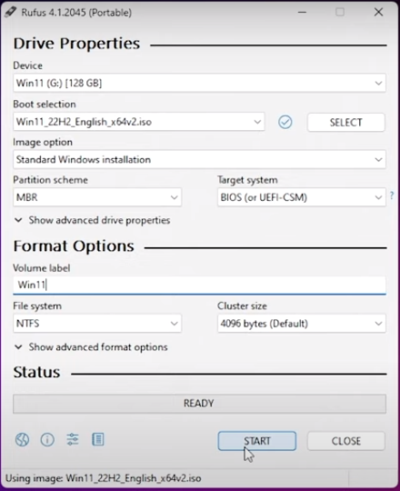
6. On the image option I selected ‘standard windows installation’ and partition scheme as MBR and clicked start.
7. I selected ‘remove 4gb RAM requirement since my laptop has a 4gb ram and clicked ok
8. After complete installation of the windows 11 into the USB drive, I shut down the laptop and turned it ON again, but during boot up I entered BIOS setting by pressing F2 and selected boot option as USB 1st priority and saved the selection by pressing F10 then began the process of installation, chose my language, entered the product key andm accepted the licensing agreement.
9. 